DCFS Cohort: New Hires

Instructions (Internal): When the 1161 form is received for hew hires, send the following email instructions.
Template: Email for Welcome Letter
Subject Line: DCFS New Hire Welcome Letter for [INSERT NAME]

Hello [NEW HIRE NAME],
We at MidSOUTH have received the 1161 form and are pleased to learn you have joined the Division of Children and Family Services as a Social Services [Specialist/Assistant/Supervisor] in [COUNTY OFFICE].
Important Note: The following activities should be completed prior to your Week 2 Classroom Training session beginning.
- Access the MidSOUTH DCFS Portal and complete the following tasks using the link below: https://www.midsouth.ualr.edu/moodle/login/index.php
  - Download the MidSOUTH Landing Page onto your desktop for use in Week 2 classroom session
  - Complete the Week 2 Pre Test (Landing Page)
  - View Chris Orientation Videos

- Please ensure that you bring your laptop, charger, and headphones to Week 2 of training to complete the Virtual Home Simulation practice activities.

Sincerely,
[Name] I Administrative Support Specialist
University of Arkansas at Little Rock | MidSOUTH
College of Business and Health & Human Services
[Address Line, City, State Zip]
[Phone Number] | [email address] | www.midsouth.ualr.edu


MidSOUTH Training Academy Locations

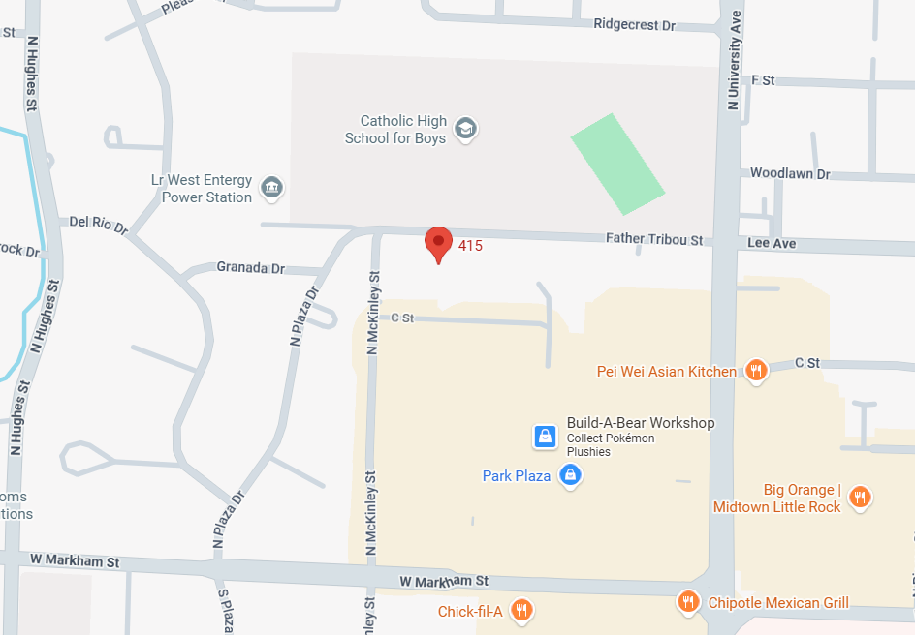  Plaza West  415 N McKinley, Suite 900  Little Rock, AR 72205  501-296-1920 | 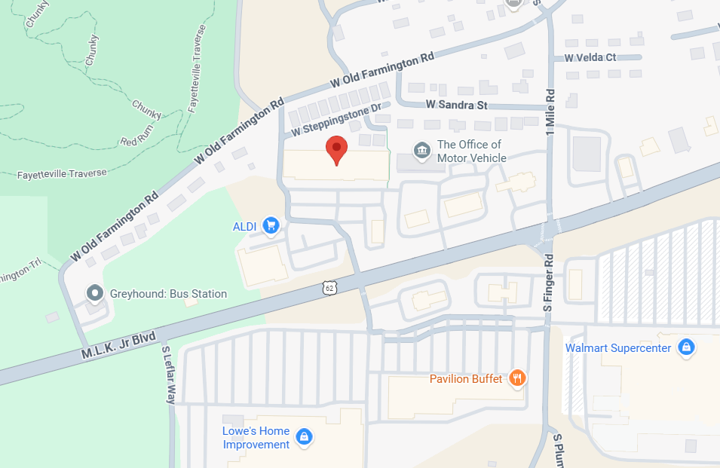  Fayetteville  3162 West Martin Luther King Blvd. Suites 6-8  Fayetteville, AR 72704  479-368-0700
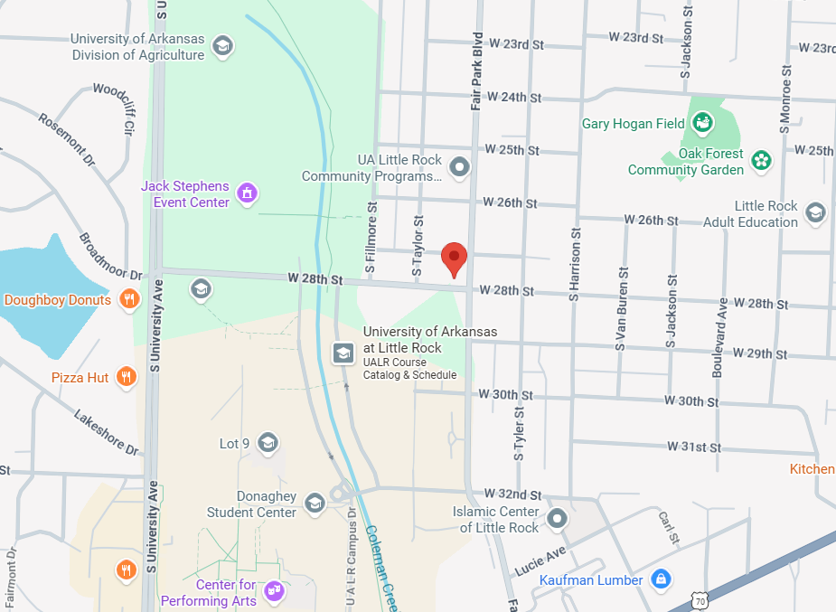  MidSOUTH Child Welfare Learning Lab  2724 Fair Park Boulevard  Little Rock AR 72204 | 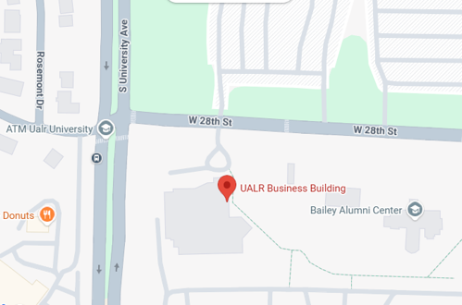  UA Little Rock Campus –  Reynolds Building (4th Floor)  2801 S University  Little Rock, AR 72204

