Arkansas
Prevention Services Directory

SFY 2020/2021

PREVENTION PROVIDERS

REGIONAL MAP

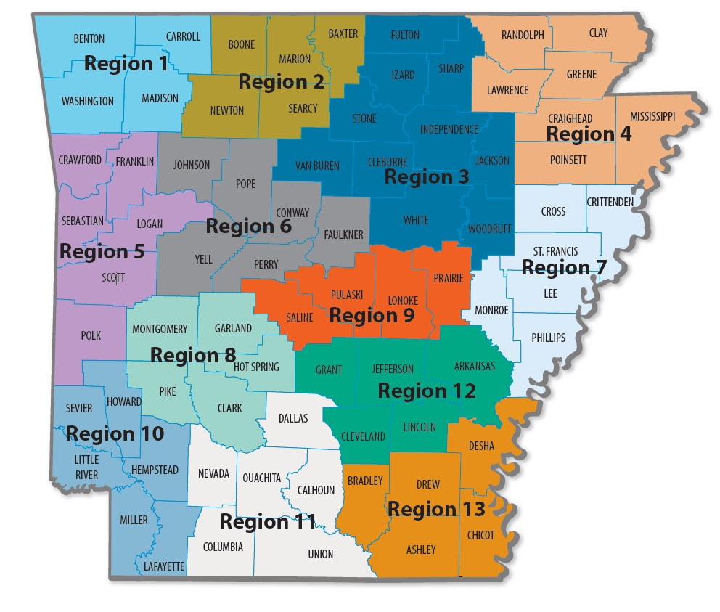

Regional Prevention Provider Information
Region Numbers and Counties | Regional  Prevention  Provider (RPP) | RPP Address  Phone Number/Fax Number | Regional  Prevention  Representative (RPR) | RPR Email Address | RPR Phone Numbers Fax Numbers | RPP Addresses
4 Region 1  Benton, Carroll,  Madison, and  Washington Counties | Community Clinic NWA | 614 E. Emma Avenue, Suite M426 Springdale, AR, 72764 Phone: (479) 751-7417 Fax: (479) 751-4898 | Laurie Reh | laurie.reh@communityclinicnwa.org | Laurie: (479) 751-7417 ext. 6187  Codi: (479) 751-7417 ext. 6816 | 614 E. Emma Avenue  Suite M426  Springdale, AR, 72764
 |  |  | Codi McCuistion | codi.mccuistion@communityclinicnwa.org
Region 2 5  Baxter, Boone, Marion,  Newton, and Searcy Counties | North Arkansas  Partnership for  Health Education | 620 N Main, Room #4311  Harrison, AR 72601  Phone: (870) 688-8352 Fax: (870) 391-3507 | Chrissie Larchez | christine.larchez@northark.edu | Office: (870) 365-6518 Fax: (870) 391-3507 | 620 N Main, Room #4311  Harrison, AR 72601
Region 3 ¹⁰  Cleburne, Fulton,  Independence, Izard,  Jackson, Sharp, Stone,  Van Buren, White, and Woodruff Counties | Crowley's Ridge Development Council, Inc. | 2013 East Main Street, Mountain View, AR 72560  Office: (870) 819-6885 Fax: (870) 935-0291 | Margaret Morrison | mmorrison@crdcnea.com | Margaret: (870) 819-6970  Barbara: (870) 819-6885 | 2013 E Main St  Mountain View, AR 72560
 |  |  | Barbara Hacker | bhacker@crdcnea.com
 |  |  | Shawn Vonwiller | svonwiller@crdcnea.com | Shawn (870) 819-7349 | 2485 Harrison Street, Suite 5, Batesville, AR 72501
Region 4 ⁷  Clay, Craighead,  Greene, Lawrence,  Mississippi, Poinsett, and Randolph Counties | Crowley's Ridge Development Council, Inc. | 2401 Fox Meadow Lane  Jonesboro, AR, 72404 Phone: (870) 933-0033 Fax: (870) 933-0048 | Lisa Perry | lperry@crdcnea.com | Office: (870) 933-0033 Fax: (870) 933-0048 | 2401 Fox Meadows Lane Jonesboro, AR, 72404
 |  |  | Deonna Vincent | dvincent@crdcnea.com
6  Region 5  Crawford, Franklin,  Logan, Polk, Scott, and Sebastian Conties | Harbor House, Inc. | 101 North 10th Street, Suite C  Fort Smith, AR 72901 (M) 3900 Armour Ave.  Fort Smith, AR 72904  Phone: (479) 785-4083 Fax: (479) 668-2059 | Tabitha Fondren | tfondren@recoveryhhi.org | Office: (479) 652-5072 Fax: (479) 783-1914 | 3900 Armour Avenue Fort Smith, AR, 72904
 |  |  | Katelynn Priest | kpriest@recoverhhi.org | Office: (479) 259-5549 Fax: (479) 783-1914
6 Region 6  Conway, Faulkner,  Johnson, Perry, Pope, and Yell Counties | Conway County  Community Service, Inc. | 100 S. Cherokee  Morrilton, AR, 72110 (M) P.O. Box 679  Morrilton, AR, 72110  Phone: (501) 354-4589 Fax: (501) 345-5410 | Shannon Cook | scook@csiyouth.com | Office: (501) 354-4589 Fax: (501) 354-5410 | 100 South Cherokee  Morrilton, AR, 72110
 |  |  | Amy Mellick | amellick@csiyouth.com | Office: (479) 967-3370 Fax: (479) 967-2775 | 1505 South Oswego Ave Russellville, AR, 72802
6 Region 7  Crittendon, Cross, Lee,  Monroe, Phillips, and  St. Francis Counties | Crowley's Ridge Development Council, Inc. | 593 Highway 243  Marianna, AR 72360  Phone: (870) 933-0033 Fax: (870) 933-0048 | Kendon Gray | kendon@crdcnea.com | Office: (870) 298-2250 Fax: (870) 298-2249 | 593 Highway 243  Marianna, AR, 72360
Region 8 ⁵  Clark, Garland, Hot  Springs, Montgomery, and Pike Counties | Ouachita Children, Youth & Family Services | 1401 Malvern Avenue, Suite 22  Hot Springs, AR 71901 Phone: (501) 282-6211 Fax: (501) 623-4226 | Anthony Tidwell | atidwell@occnet.org | Office: (501) 915-4050  Fax: (501) 623-4226 | 1401 Malvern Avenue, Suite 22  Hot Springs, AR 71901
4  Region 9  Lonoke, Prairie,  Pulaski, and Saline Counties | Family Service Agency, Inc. | (P) 628 W. Broadway  Suite #300  North Little Rock, AR, 72114  Phone: (501) 372-4242 Fax: (501) 372-4758 | Hayse Miller | hmiller@fsainc.org | Office: (501) 372-4242 Ext.  753  Fax: (501) 372-4758  Direct: (501) 301-1753 | 628 West Broadway Street  Suite 300  North Little Rock, AR, 72114
 |  |  | Genine Perez | gperez@fsainc.org | Office: (501) 372-4242 Ext.  752  Fax: (501) 372-4758  Direct: (501) 301-1752
Region 10 ⁶  Hempstead, Howard,  Lafayette, Little River,  Miller, and Sevier Counties | Harbor House, Inc. | (P) 4425 Jefferson Ave., Suite 102  Texarkana, AR 71854  Phone: (903) 733-7564 Fax: (479) 668-2059 | Trena Goings | tgoings@recoveryhhi.org | Office: (870) 773-0997 Fax: (870) 773-0994 | 4425 Jefferson Avenue Suite 102  Texarkana, AR, 71854
6 Region 11  Calhoun, Columbia,  Dallas, Nevada,  Ouachita, and Union Counties | Harbor House, Inc. | 124 S. Jackson Street Suite 411  Magnolia, AR 71754 Phone: (870) 901-3551 Fax: (870) 901-3552 | Tamara Iverson | tiverson@recoveryhhi.org | Office: (870) 901-3551 Fax: (870) 901-3552 | 124 S. Jackson Street  Suite 411  Magnolia, AR, 71754
5 Region 12  Arkansas, Cleveland,  Grant, Jefferson, and Lincoln Counties | Community  Empowerment  Council, Inc. | 4701 Dollarway Road  Pine Bluff, AR 71602  Phone: (870) 534-2047  Fax: (870) 534-2036 | Tanishia Lewis | tanishialewis@cecemp.org | Phone: (870) 534-2047  Fax: (870) 534-2036 | 4701 Dollarway Road  White Hall, AR, 71602
 |  |  | A. Jermaine Anderson | jermaineanderson@cecemp.org
5 Region 13  Ashley, Bradley,  Chicot, Desha, and Drew Counties | Phoenix Youth and Family Services | (P) 310 North Alabama Street  Crossett, AR, 71635 (M) P.O. Box 654  Crossett, AR, 71635  Phone: (870) 364-1676 Fax: (870) 364-1779 | Roshunda Davis-Johnson | rdavis@phoenixyouth.com | Office: (870) 364-1676  Fax: (870) 364-1779 | 310 North Alabama Street Crossett, AR, 71635
2801 South University Avenue, DKSN 622 Little Rock, AR, 72204 (501) 859-0363 | (501) 569-3364 – Fax

Partnerships For Success Regional Lead Agency (RLA) Information
Region Numbers and Counties | Regional  Lead Agencies (RLA) | RLA Address  Phone Number/Fax Number | Regional  Lead Representatives (RLR) | RLR Email Address | RLR Phone Numbers Fax Numbers | RLA Addresses
4 Region 1  Benton, Carroll,  Madison, and  Washington Counties | Community Clinic NWA | 614 E. Emma Avenue, Suite 300 Springdale, AR, 72764 Phone: (479) 530-6160 Fax: (479) 751-4898 | Deb Crawford | deb.crawford@communityclinicnwa.org | Office: (479) 530-6160  Fax: (479) 751-4898 | 614 E. Emma Avenue  Suite M300  Springdale, AR, 72764
Region 2 5  Baxter, Boone, Marion,  Newton, and Searcy Counties | North Arkansas  Partnership for  Health Education | 620 N Main, Room #4134  Harrison, AR 72601  Phone: (870) 391-3176  Fax: (870) 391-3507 | Kyle Evatt | Kyle.evatt@northark.edu | Office: (870) 391-3176  Fax: (870) 391-3507 | 1515 Pioneer Drive Harrison, AR 72601
Region 3 ¹⁰  Cleburne, Fulton,  Independence, Izard,  Jackson, Sharp, Stone,  Van Buren, White, and Woodruff Counties | Crowley's Ridge Development Council, Inc. | 2000 McClain Street, Building 1 Suite C Newport, AR 72112 Office: (870) 520-0713 Fax: (870) 935-0291 | Stacy Taylor | staylor@crdcnea.com | Office: (870) 520-0713 Fax: (870) 935-0291 | 2485 Harrison Street Suite 5 Batesville, AR 72501
Region 4 ⁷  Clay, Craighead,  Greene, Lawrence,  Mississippi, Poinsett, and Randolph Counties | Crowley's Ridge Development Council, Inc. | 2401 Fox Meadow Lane  Jonesboro, AR, 72404 Phone: (870) 933-0033 Fax: (870) 933-0048 | Juan Sheppard | jsheppard@crdcnea.com | Office: (870) 520-9394 Fax: (870) 933-0048 | 2401 Fox Meadow Lane Jonesboro, AR, 72404
6  Region 5  Crawford, Franklin,  Logan, Polk, Scott, and Sebastian Conties | Harbor House, Inc. | 101 North 10th Street, Suite C  Fort Smith, AR 72901 (M) 3900 Armour Ave.  Fort Smith, AR 72901  Phone: (479) 259 – 3393 Fax: (479) 668-2059 | Jadyn McGrew | jketter@recoveryhhi.org | Office: (479) 259 – 3393 Fax: (479) 783-1914 | 101 North 10th Suite C Fort Smith, AR 72901
6 Region 6  Conway, Faulkner,  Johnson, Perry, Pope, and Yell Counties | Conway County  Community Service, Inc. | 100 S. Cherokee  Morrilton, AR, 72110 (M) P.O. Box 679  Morrilton, AR, 72110  Phone: (501) 354-4589 Fax: (501) 345-5410 | Kelli Bingham | kbingham@csiyouth.com | Office: (501) 354-4589 Fax: (501) 354-5410 | 100 South Cherokee  Morrilton, AR, 72110
6 Region 7  Crittendon, Cross, Lee,  Monroe, Phillips, and  St. Francis Counties | Crowley's Ridge Development Council, Inc. | 593 Highway 243  Marianna, AR 72360  Phone: (870) 298-2249 Fax: (870) 933-0048 | Marquisha Applewhite | mapplewhite@crdcnea.com | Office: (870) 298-2249 Fax: (870) 933-0048 | 593 Highway 243  Marianna, AR, 72360
Region 8 ⁵  Clark, Garland, Hot  Springs, Montgomery, and Pike Counties | Ouachita Children, Youth & Family Services | 339 Charteroak Hot Springs, AR 71901  Phone: (501) 623-5592 Fax: (501) 623-4226 | Ashley Thompson | athompson@occnet.org | Office: (501) 623-5592 Fax: (501) 623-4226 | 339 Charteroak Hot Springs, AR 71901
4  Region 9  Lonoke, Prairie,  Pulaski, and Saline Counties | Center for Healing Hearts and Spirits | 2416 South Chester Street  Little Rock, AR 72206Phone: 501-372-3800 Fax: (501) 372-4758 | Shakela Fortson | sfortson.chhs@gmail.com | Office: 501-372-3800  Fax: (501) 372-4758 | 2416 South Chester Street  Little Rock, AR 72206
Region 10 ⁶  Hempstead, Howard,  Lafayette, Little River,  Miller, and Sevier Counties | Harbor House, Inc. | 4425 Jefferson Ave., Suite 102 Texarkana, AR 71854 Phone: (479) 785-4083 Fax: (479) 668-2059 | Kita Cantu | kita.cantu@recoveryhhi.org | Office: (479) 785-4083 Fax: (870) 773-0994 | 4425 Jefferson Avenue Suite 102  Texarkana, AR, 71854
6 Region 11  Calhoun, Columbia,  Dallas, Nevada,  Ouachita, and Union Counties | Harbor House, Inc. | 124 S. Jackson Street Suite 411  Magnolia, AR 71754 Phone: (870) 901-3551 Fax: (870) 901-3552 | Alex Smith | asmith@recoveryhhi.org | Office: (870) 901-3551 Fax: (870) 901-3552 | 124 S. Jackson Street  Suite 411  Magnolia, AR, 71754
5 Region 12  Arkansas, Cleveland,  Grant, Jefferson, and Lincoln Counties | Community  Empowerment  Council, Inc. | 2501 S. Cherry Street Pine Bluff, AR 71601  Phone: (870) 536-8484  Fax: (870) 534-2036 | Tempest Alexander | t.smith@cecemp.org | Phone: (870) (870) 536-8484  Fax: (870) 534-2036 | 4701 Dollarway Road White Hall, AR 71602
5 Region 13  Ashley, Bradley,  Chicot, Desha, and Drew Counties | Phoenix Youth and Family Services | (P) 310 North Alabama Street  Crossett, AR, 71635 (M) P.O. Box 654  Crossett, AR, 71635  Phone: (870) 364-1676 Fax: (870) 364-1779 | Nikkia Davidson | ndavidson@phoenixyouth.com | Office: (870) 364-1676  Fax: (870) 364-1779 | 310 North Alabama Street Crossett, AR, 71635

2801 South University Avenue, DKSN 622 Little Rock, AR, 72204 (501) 859-0363 | (501) 569-3364 – Fax

Contract Contact Information
Contract Agency | Contract Agency Address | Contract Contact | Contract Contact Email | Contract Contact Phone Number
Arkansas Collegiate Drug  Education Committee (ACDEC) | P.O. Box 591  North Little Rock, AR, 72115 | Amber Long Martin | along@astate.edu | Office: (870) 972-2318 Fax: (870) 972-3375
Arkansas Department of Health -  Health Statistics Branch (SYNAR) | 4815 West Markham  Slot H-19  Little Rock, AR, 72205 | Amie Lein | amie.lein@arkansas.gov | Office: (501) 280-4065 Fax: (501) 661-2544
 |  | Mary McGehee | mary.mcgehee@arkansas.gove | Office: (501) 661-2633 Fax: (501) 661-2544
Arkansas Foundation for Medical Care, Inc.  (Archival Risk Factor,  Partnership for Success,  Statewide Epilogical  Outcomes Workgroup) | 1020 West 4th Street  Suite 300  Little Rock, AR, 72201 | Melanie Boyd | mboyd@afmc.org | Office: (501) 212-8718 Fax: (501) 212-8782
 |  | Kent Thompson | kthompson@afmc.org | Office: (501) 212-8622 Fax: (501) 212-8782
FEI.com dba FEi Systems (WITS Databse) | 9755 Patuxent Woods Drive Suite 300  Columbia, Maryland, 21046 | Kory Schnoor | kory.schnoor@feisystems.com | Office: (443) 867-1047 Fax: (410) 715-6538
International Survey  Associates, LLC. dba Pride  Surveys  (Arkansas Prevention  Needs Assessment [APNA] Survey) | 2140 Newmarket Parkway SE  Suite 116  Marietta, GA, 30067 | Melissa Stephens | melissa.stephens@pridesurveys.com | Office: (800) 279-6361 Fax: (770) 726-9327
 |  | Jay Gleaton | jay.gleaton@pridesurveys.com | Office: (800) 279-6361 Fax: (770) 726-9327
University of Arkansas for Medical Sciences  Center for Addiction Research | 4301 West Markham Street, Slot 843  Little Rock, AR 72205 | Alison Oliveto | aoliveto@uams.edu | Office: (501) 526-8441 Fax: (501) 526-7816
University of Wyoming  Wyoming Survey & Analysis Center | 406 S. 21st st., Laramie, WY 82070 | Rodney A. Wambeam | Rodney@uwyo.edu | Office: (307) 760-8928 Fax: (307) 766-2189
MidSOUTH Prevention Staff
UALR Little Rock  MidSOUTH | 2801 South University Avenue  DKSN 622  Little Rock, AR 72204  Fax: (501) 569-3364 | Jessica Simpson | jlsimpson@midsouth.ualr.edu | Office: (501) 859-0363  Cell: (501) 831-9380
 |  | Darla Kelsay | djkelsay@midsouth.ualr.edu | Office: (501) 859-0363 Cell: (501) 951-8959
 |  | Rohan Sharma | rxsharma@midsouth.ualr.edu | Office: (501) 859-0363 Cell: (501) 690-6134
 |  | Derrick Newby | dlnewby@midsouth.ualr.edu | Office: (501) 859-0362 Cell: (501) 951-8924
 |  | Rosalie Shahan | rsshahan@midsouth.ualr.edu | Office: (501) 859-0364 Cell: (501) 553-4453
 |  | Chuks Odor | ccodor@midsouth.ualr.edu | Office: (501) 569-8237  Cell: (501) 838-2050
 |  | Pam Plummer | plplummer@midsouth.ualr.edu | Office: (501) 412- 5449
 |  | Adam Baldwin | apbaldwin@midsouth.ualr.edu | Office: (501) 859-8321 Cell: (501) 509-0345
DBHS Prevention Staff
Arkansas Department of Health Services  Division of Aging, Adults  Behavioral Health Services | Prevention Services  305 South Palm Street Little Rock, AR, 72205  Fax: (501) 686-9396 | Kymala Calloway | kymala.calloway@dhs.arkansas.gov | Office: (501) 686-9030
 |  | Joycelyn Pettus | joycelyn.pettus@dhs.arkansas.gov | Office: (501) 686-9921
 |  | Tenesha Barnes | tenesha.barnes@dhs.arkansas.gov | Office: (501) 686-9982
2801 South University Avenue, DKSN 622 Little Rock, AR, 72204 (501) 859-0363 | (501) 569-3364 - Fax

