Arkansas Regional Lead Agency Directory

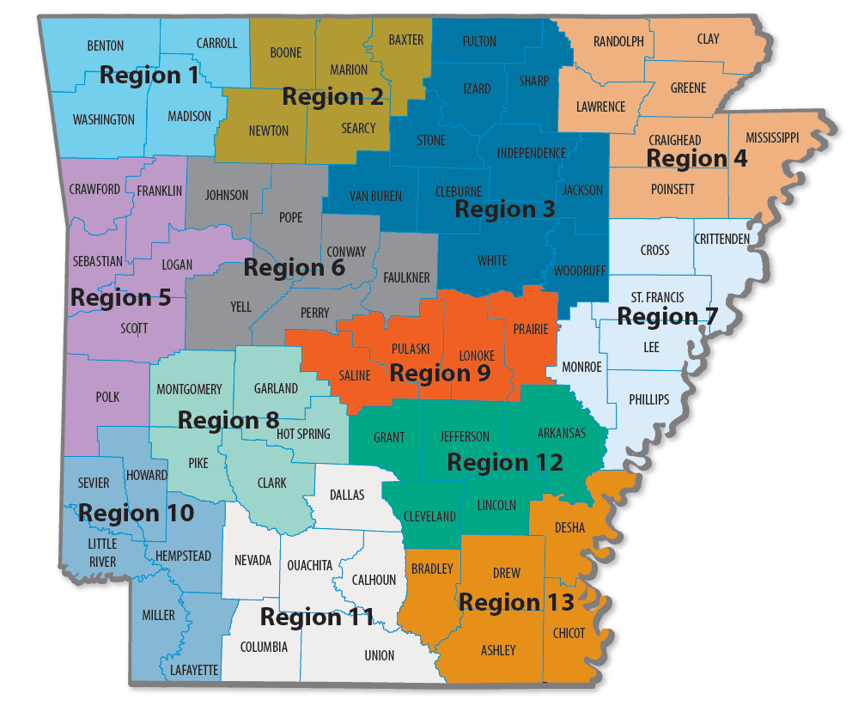

Region 1 – Benton, Carroll, Madison, Washington Counties
Northwest Arkansas Tobacco and Drug Free – (479) 751-7417 x6011 Fax: (479) 927-2752
dba Community Clinic
Address: 614 E. Emma Avenue, Suite 300
Springdale, AR 72764
Deb Crawford- deb.crawford@communityclinicnwa.org

Region 2 – Baxter, Boone, Marion, Newton, Searcy
North Arkansas Partnership for Health Education
Mailing Address: 620 North Main West Tower Room 4134
Harrison, AR 72601
Cell: 870-416-2039 Fax: (870) 391-3176
Jennifer Wilson - jennifer.wilson@northark.edu
Daniel Dillard – daniel.dillard@northark.edu

Region 3 – Cleburne, Fulton, Independence, Izard, Jackson, Sharp, Stone, Van Buren, White and Woodruff
Crowley’s Ridge Development Council, Inc - 870-273-2921
Address: 2000 McClain Street, Building 1 Suite C Newport, AR 72112
Stacy Taylor-870-520-0713 staylor@crdcnea.com

Region 4 – Clay, Craighead, Greene, Lawrence, Mississippi, Poinsett, and Randolph
Crowley’s Ridge Development Council, Inc – (870) 933-0033 Fax: (870) 933-0048
Address: 2401 Fox Meadow Lane, Jonesboro, AR 72404
Juan Sheppard jsheppard@crdcnea.com

Region 5- Crawford, Franklin, Logan, Polk, Scott, and Sebastian
Harbor House, Inc. - (479) 785-4083 ext. 212 or 204 / Fax: (479) 783-1914
Address: 101 North 10th Suite C
Fort Smith, AR 72901
Jadyn Ketter- (479)259-3393 jketter@recoveryhhi.org

Region 6 – Conway, Faulkner, Johnson, Perry, Pope, and Yell
Conway County Community Service Inc. (501) 354-4589 Fax: (501) 354-5410
Physical Address: 100 South Cherokee, Morrilton, AR 72110
Mailing Address: PO BOX 679, Morrilton, AR 72110
Kelli Bingham – 501-977-3088 kbingham@csiyouth.com

Region 7 – Crittenden, Cross, Lee, Monroe, Phillips, and St. Francis
Crowley’s Ridge Development Council, Inc. – (870) 298-2249 Fax: (870) 298-2249
Address: 593 Highway 243
Marianna, AR 72360
Marquisha Applewhite-870.520.8286 mapplewhite@crdcnea.com

Region 8 – Clark, Garland, Hot Spring, Montgomery, and Pike
Ouachita Children’s Center, Inc.
Address: 339 Charteroak Alt Address: PO Box 1180, 71902
Hot Springs, AR 71901
Office: (501) 623-5592 Alt: (501) 623-5591
Ashley Thompson-501-282-6211 athompson@occnet.org

Region 9 – Saline, Pulaski, Lonoke, and Prairie
Women’s Council on African American Affairs, Inc.
Address: 2416 South Chester Street
Little Rock, AR 72206
501-372-3800 or 501-352-4325
Morgan Jackson- (501)-372-3800 morganj.chhs@gmail.com
Region 10 – Hempstead, Howard, Lafayette, Little River, Miller, and Sevier
Harbor House – (479) 785-4083 (501)547-0785
Address: 4425 Jefferson Ave., Suite 102
Texarkana, AR 71854
Kita Cantu kita.cantu@gmail.com

Region 11 – Calhoun, Columbia, Dallas, Ouachita, Nevada, and Union
Harbor House – (870) 901-3551 Fax: (870) 901-3552
Address: 124 S. Jackson Street. Suite 411
Magnolia, AR 71754
Alex Smith - asmith@recoveryhhi.org or Alex.Randolph.Smith@gmail.com

Region 12 – Arkansas, Cleveland, Grant, Jefferson, and Lincoln
Community Empowerment Council Inc. – (859) 457-0245 or (870) 536-2722
Fax: (870) 534-1113
Address: 2501 S. Cherry Street
Pine Bluff, AR 71601
Tempest Alexander – t.smith@cecemp.org

Region 13 – Ashley, Bradley, Chicot, Desha, Drew
Phoenix Youth & Family Services – (870) 364-1676 ext. 3 Fax: (870) 364-1779
Address: 310 North Alabama Street, PO Box 654
Crossett, AR 71635
Nikkia Davidson, PFS Coordinator rdavis@phoenixyouth.com

Statewide Coordinator: UA Little Rock/MidSOUTH Center for Prevention & Training
MidSOUTH Partnership for Success – 501-859-0362
Derrick Newby – dlnewby@midsouth.ualr.edu

