Arkansas Regional Prevention Provider Directory

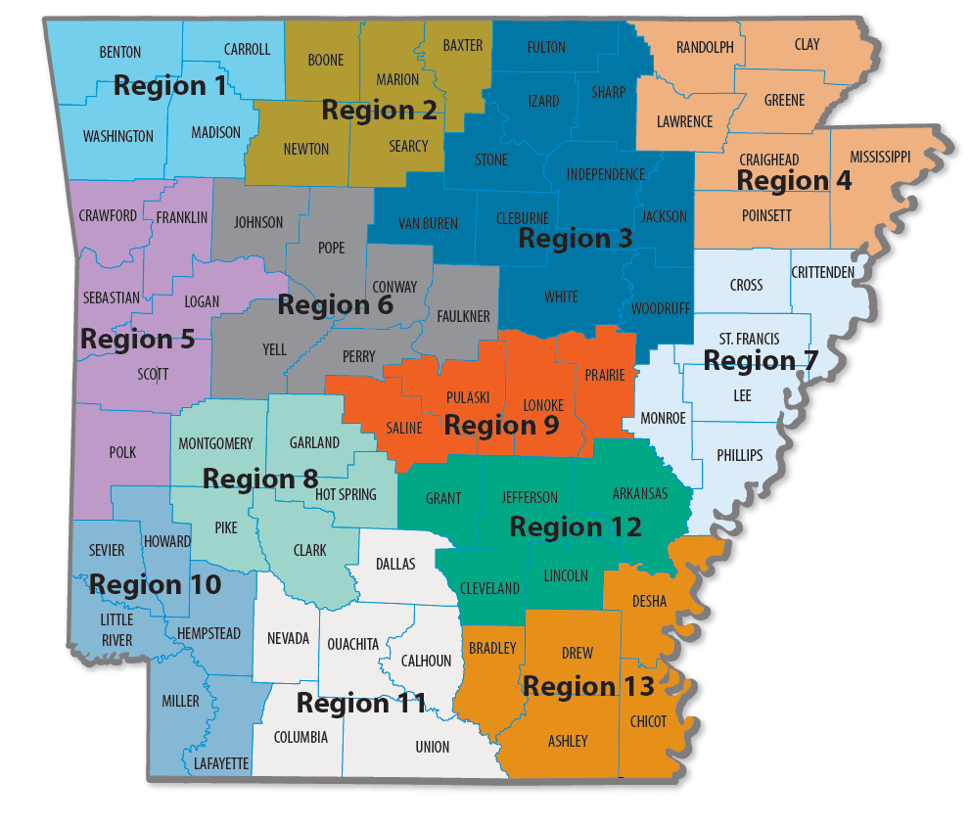

Region 1 – Benton, Carroll, Madison, Washington Counties
Quapaw House, Inc. – (479) 927-2655 Fax: (479) 927-2752
Address: 614 E. Emma Avenue, Suite M426
Springdale, AR 72764
Laurie Reh - lauriereh@quapawhouseinc.org
Codi McCuistion - codimccuistion@quapawhouseinc.org

Region 2 – Baxter, Boone, Marion, Newton, Searcy
North Arkansas Partnership for Health Education
Address: 303 N. Main
Harrison, AR 72601
Cell: 870-365-6518 Fax: (870) 391-3507
Cindy DeWitt – cindy.dewitt@northark.edu

Region 3 – Cleburne, Fulton, Independence, Izard, Jackson, Sharp, Stone, Van Buren, White and Woodruff
Quapaw House, Inc. – (501) 745-5640
Address: 244 Hwy 65 South, Suite 6, Clinton, AR 72031
Margaret Morrison - margaretmorrison@quapawhouseinc.org

Address: 25 Gap Road
Batesville, AR 72501
Office: (870) 698-9532
Stacy Taylor - stacytaylor@quapawhouseinc.org
Region 4 – Clay, Craighead, Greene, Lawrence, Mississippi, Poinsett, Randolph
Crowley’s Ridge – (870) 933-0033 Fax: (870) 933-0048
Address: 2401 Fox Meadows Lane
Jonesboro, AR 72404
Dr. Lisa Perry – lperry@crdcnea.com

Region 5- Crawford, Franklin, Logan, Polk, Scott, Sebastian
Harbor House - (479) 785-4083 ext. 212 or 204 / Fax: (479) 783-1914
Address: 3900 Armour Avenue
Fort Smith, AR 72904
Tabitha Fondren - tfondren@recoveryhhi.org
Katie Priest - kpriest@recoveryhhi.org

Region 6 – Conway, Faulkner, Johnson, Perry, Pope, Yell
Community Service Inc. (501) 354-4589 Fax: (501) 354-5410
Physical Address: 100 South Cherokee, Morrilton, AR 72110
Mailing Address: PO BOX 679, Morrilton, AR 72110
Shannon Cook - scook@cisyouth.com

Address: 1505 South Oswego Avenue
Russellville, AR 72802
Office: (479) 967-3370 Fax: (479) 967-2775
Amy Mellick - amellick@cisyouth.com

Region 7 – Crittenden, Cross, Lee, Monroe, Phillips, St. Francis
Crowley’s Ridge – (870) 298-2249 Fax: (870) 298-2249
Address: 593 Highway 243
Marianna, AR 72360
Kendon Gray - kendon@crdcnea.com
Cell: (870) 819-7756

Region 8 – Clark, Garland, Hot Spring, Montgomery, Pike
CHI St. Vincent
Address: 1 Mercy Lane Suite 507B
Hot Springs, AR 71913
Lindsay Mulkey – lindsaymulkey@catholichealth.net
Office: (501) 622-4112 (Lindsay) (501) 622-4116 (Katie)
Fax: (501) 622-1278
Region 9 – Saline, Pulaski, Lonoke, Prairie
Family Service Agency – (501) 372-4242 ext. 752 (Hayse) or 753 (Genine)
Fax: (501) 372-4758
Address: 628 West Broadway Street Suite 300

North Little Rock, AR 72114
Hayse Miller - hmiller@fsainc.org
Genine Perez - gperez@fsainc.org

Region 10 – Hempstead, Howard, Lafayette, Little River, Miller, Sevier
Harbor House – (501) 517-1862
Address: 600 Walnut Street
Texarkana, AR 71854
Trena Goings - tgoings@recoveryhhi.org

Region 11 – Calhoun, Columbia, Dallas, Ouachita, Nevada, Union
Harbor House – (870) 901-3551 Fax: (870) 901-3552
Address: 124 S. Jackson Street Suite 411
Magnolia, AR 71754
Alex Smith - asmith@recoveryhhi.org

Region 12 – Arkansas, Cleveland, Grant, Jefferson, Lincoln
Community Empowerment Council Inc. – (870) 738-8549 or (870) 536-2722
Fax: (870) 536-8500
Address: 4701 Dollarway Road
Pine Bluff, AR 71602
Jermaine Anderson – jermaineanderson@cecemp.org
Tanishia Lewis – tanishialewis@cecemp.org

Region 13 – Ashley, Bradley, Chicot, Desha, Drew
Phoenix Youth & Family Services – (870) 364-1676 ext. 3 Fax: (870) 364-1779
Address: 310 North Alabama Street
Crossett, AR 71635
Christie Lindsey - clindsey@phoenixyouth.com

Statewide Coordinator: UA Little Rock/MidSOUTH Center for Prevention & Training
MidSOUTH Substance Abuse Prevention Coordinator Office – 501-859-0363
Darla Kelsay – djkelsay@midsouth.ualr.edu
Stephen McElroy – swmcelroy@midsouth.ualr.edu

