HOPE
Changing brains through support, structure, and
confronting shame
Dr. Margo Turner
Dr.margo.turner@gmail.com
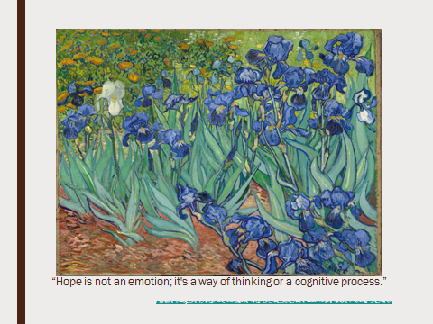

The 5

4 square – 2 facts and 1 question

Recognition/Belonging

Skill-Building/Self-Regulation

Space/Time

Resources:

- http://stateofopportunity.michiganradio.org/post/five-things-know-about-early-childhood-brain-development Dr. Jack Shonkoff, director of the Center on the Developing Child at Harvard University.
- The Learning Brain: Memory and Brain Development in Children by Torkel Klingberg
- http://www.ascd.org/publications/educational-leadership/may13/vol70/num08/How-Poverty-Affects-Classroom-Engagement.aspx
- Eric Jensen, (Teaching with Poverty in Mind), 2009 ASCD
- http://www.zerotothree.org/child-development/brain-development/baby-brain-map.html
- http://www.angeresources.com/helpkids.html
- https://www.zerotothree.org/resources/304-how-to-introduce-toddlers-and-babies-to-books
- https://www.naeyc.org/files/yc/file/201107/Self-Regulation_Florez_OnlineJuly2011.pdf
- http://www.mikewirthart.com/project/child-brain-development-happy-family-brands/
- Dr. Bruce Perry, www.childtrauma.org
- http://www.ascd.org/publications/educational-leadership/may13/vol70/num08/How-Poverty-Affects-Classroom-Engagement.aspx

